MARCH –APRIL 2024
St. Patrick’s Newsletter
This Photo by Unknown Author is licensed under CC BY-SA
This Photo by Unknown Author is licensed under CC BY-SA
Living and Learning, Today and Tomorrow

P7 Olympic Handball
Congratulations to our fantastic P7 Olympic Handball teams, who recently took up the sport with the support of Eugene Mc Kenna, Ulster Games Development Officer.

The P7 boys and girls in our school continue to make sporting history for our school. Having already secured Belfast Schools' Gaelic titles in the Autumn term the pupils then turned their attention to trying a new sport - Olympic Handball.

The Boys and Girls team participated in the regional finals in Lisburn on 22nd February. They put their super Gaelic handling skills to good use to
come through the group stages unbeaten and qualified for the finals. In two nail biting games the children came out on top against Portstewart P.S. to clinch a remarkable double.
The squads now qualify for the All-Ireland finals in April at the University of Limerick and are now fundraising for the trip. We have secured sponsorship from several local businesses including the Baytree, Hunt Solicitors, Declan Murphy Finance, Paper Owl Productions and DK coaching to date. We are very grateful for these valuable contributions.
Exclusive School Concert
Arco String Quartet (Clare & Richard Hadwen) are also performing a special concert, weaving classical threads into modern melodies, in the school hall on 11th April at 7pm to support the fundraising efforts for the school steams to attend the finals days in Limerick. Tickets are £20 and are available from Mr Sherlock directly.

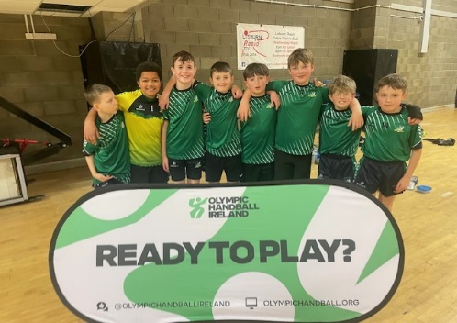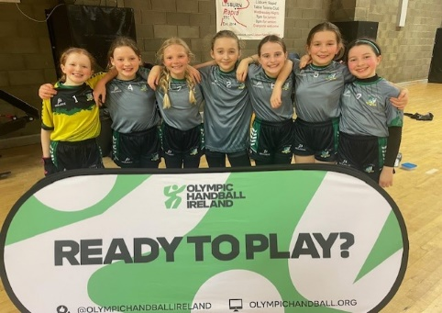

P7 Post Primary Application Processing Meetings
After all the P7 children hard work, the P7 parents faced into the onerous task of making the post-primary school applications in February. I was so impressed with how organised our P7 parents were in making their applications online.
All applications have been submitted on time, so well done to everyone. Placement letters will be available online via the EA portal on Saturday 18th May.

P1-P6 Parent Teacher Meetings
Thank you to everyone, who attended the PTM in February. Our next parental consultation will be the end of year school report.

Sacramental News

Congratulations to our super P3 Boys & Girls who celebrated the sacrament of First Confession with Fr. Mc Brearty, their parents, grandparents and family members. Thank you to Mrs Hamill, Mrs Beegan, Mrs Wilkinson, Mrs Knight and Ms Sloan for preparing the children for their faith journey.

Upcoming Sacramental events

TBC | P7 - Service of Commitment & Light  All Confirmation candidates should have a parent present for this Service
Thursday 13th June @ Time TBC | P7 – Confirmation
Saturday 15th June @ 11am | P4 – First Communion

The class teachers and children have been busy organising a range of events to support our Lenten fundraiser for Trocaire during Lent.

There are three Easter Egg Hampers to be raffled on 26th March. Tickets are 50p each.

World Book Day Friday 8th March
The children celebrated World Book Day by dressing up as their favourite character. Every child will receive a free book as part of the celebration next week. Lots of photographs are available on the school website https://www.stpatrickspsholywood.com/.

This Photo by Unknown Author is licensed under CC BY
St. Patricks P.S. ICT Fund Update

As you may be aware, the St Patrick’s PS staff - led by Mrs Orr - have developed a comprehensive Information Communication Technology (ICT) Curriculum from P1 to P7. Our pupils experience a curriculum that fully meets the requirements of the NI Curriculum for ICT.

Our pupils have developed their ICT skills in Publishing, Presenting, Coding, Managing Data, Art & Design, Music & Sound, Film & Animation and thoroughly enjoy the learning that takes place.

Through our fund-raising initiative we have purchased additional I-pads for the use of all the pupils and staff. The EA Contract for ICT is changing in September, so we aim to purchase new laptops and PCs.

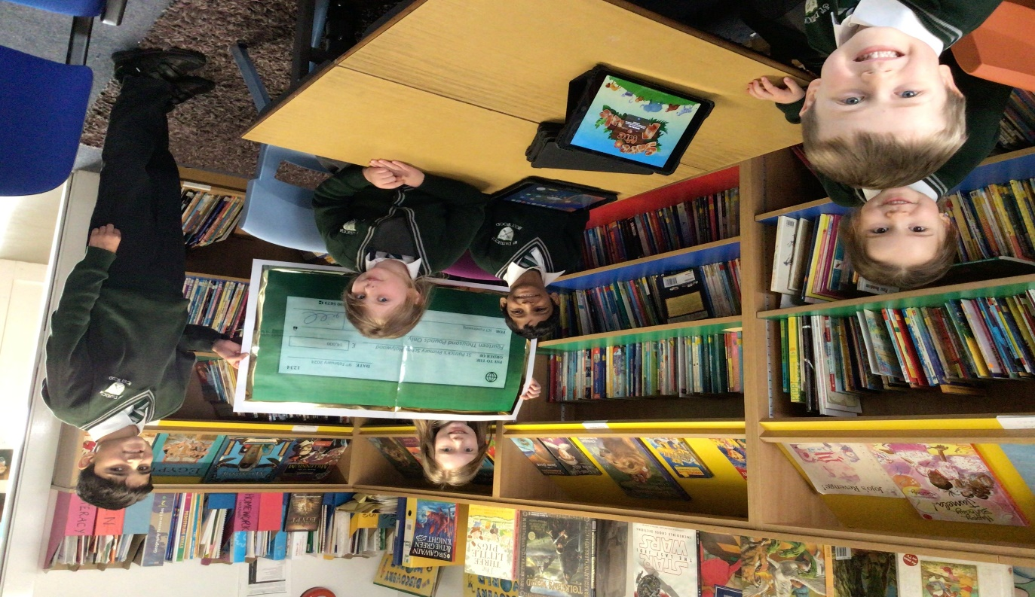

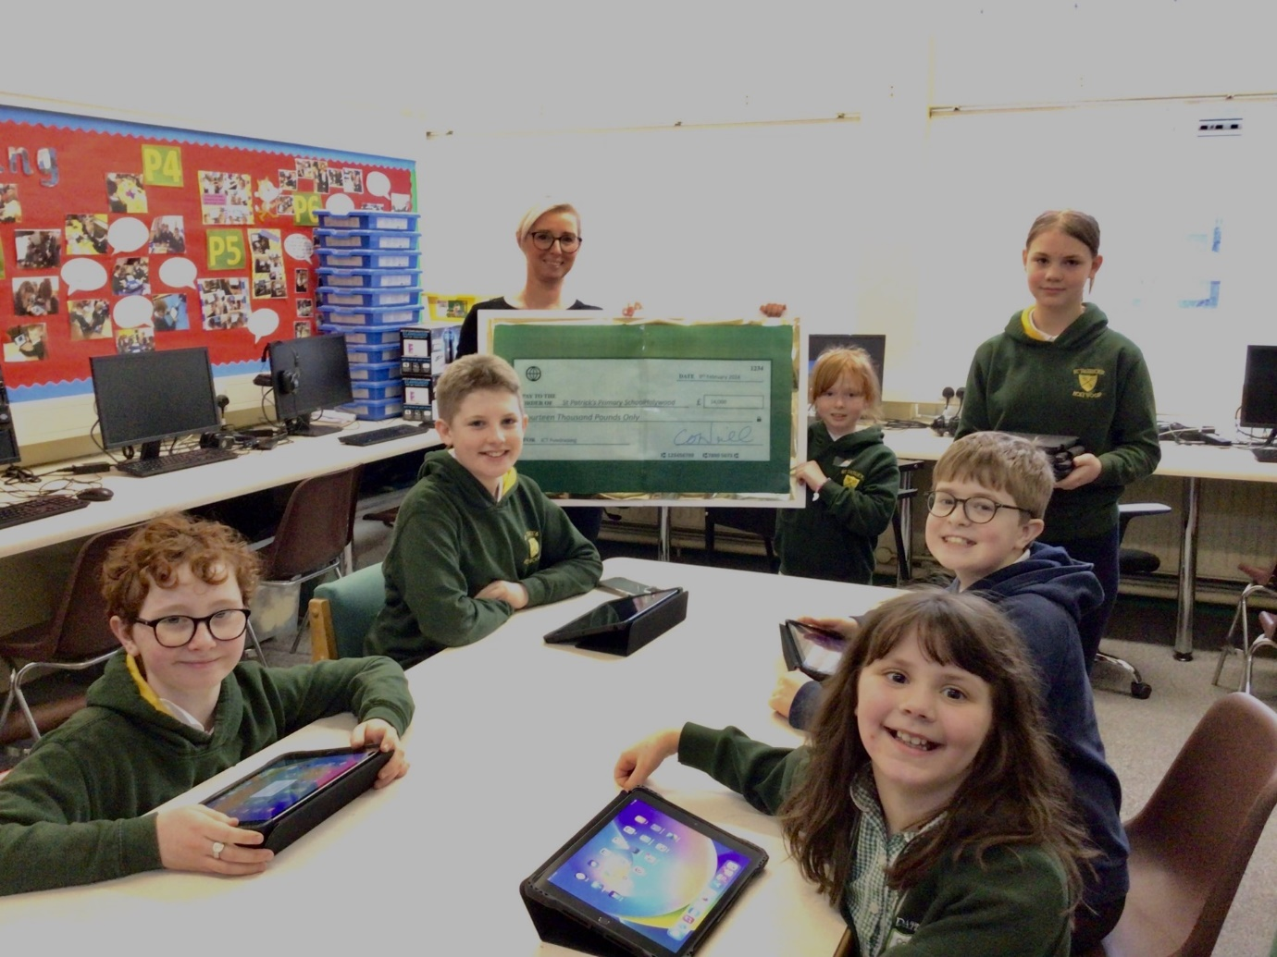

CAR PARKING
Car Parking and accessing school grounds before and after the school day. Please kindly note the following procedures, pedestrian access is by the Ean Hill and Church View gates only. Access via the main gate is for vehicle access only and anyone accessing this gate does so at their own risk.
Parents or Grandparents should not block this gate or access the car park in their vehicles. I would ask all school users to remain vigilant with respect to road safety in around the school grounds and the local neighbourhood.
+++++++++++++++++++++++++++++++++++++++++++++++++++++++++++++++++++++++++++++++++++++++++
School Attendance Matters

School attendance does really matter. It is vital that your child attends school to receive a good education and minimise any gaps in their learning.
The current overall attendance for the school is 95%.

The impact of missed days is highlighted in this link.

https://www.education-ni.gov.uk/sites/default/files/publications/de/attendance-matters-a-parents-guide.pdf

- A 90% attendance rate may seem to be good, but it actually equates to missing 4 weeks of school.
- 95 % is deemed satisfactory by the Department of Education.
- Unagreed holidays during term time have a significant impact on attendance.

Recording Absence on school rolls
Please note that it is a parental responsibility to inform the school of a child’s absence.
On your child’s attendance certificate, a D- code denotes ‘did not provide a reason for absences’. This is a poor reflection and adds to the class teacher’s workload.
Parents can explain an absence by
- Phone call to the office – 028 90 424772
- Email to info@stpatsps.holywood.ni.sch.uk
- A note into the class teacher.

=========================================================================

BUG CLUB READING Challenge

Bug Club / Principals Award certificates for every child who completes all their reading challenges for Term 2. The cut-off date for completion bug books will be Monday 25th March.

Why we use Bug Club?
Bug Club is the minimum requirement for reading homework as it is reflective of each child’s reading skills. It is carefully chosen and managed by the class teacher to meet the interests of their reading groups. It provides a comprehension-based task to help your child’s retrieval and simple and complex inference skills. It also extends the range of genre that the children experience and the variety of authorial techniques.
These are all key skills in supporting reading skills, learning and preparation for PTE, PTM, CAT4 and SEAG testing cycles. Bug is easily monitored by the class teacher.

Promoting a reading culture at school and at home
In school, the staff are taking steps to encourage a reading for pleasure culture throughout the year groups by reading to their classes on a daily/weekly basis.
We aim to re-open the school library as a lending library after the Easter break.

Reading at home should not be limited to bug club. The use of books to read for pleasure are always encouraged. We would encourage parents to read to their child on a daily / weekly basis e.g., at bedtime. Visits to the local EA library and local charity book shops are encouraged- The CONCERN Bookshops have a wide of books for children available.

DIARY DATES

Diary dates – all up to date diaries are available on
https://www.stpatrickspsholywood.com/parents/calendar/?caltags=

Don’t Forget to book a ticket for the Spring Concert on Thursday 21st or Friday 22nd, P4-P6 will be performing along with the Choir, Orchestra and Traditional Group.
Order letters have been sent home or available from the office.

This Photo by Unknown Author is licensed under CC BY-SA

Road Safety Education

The recently produced road safety guides for parents (of children 0-7 years & 8-11 years) are now both available to download on NI Direct – in English and Irish at: https://www.nidirect.gov.uk/publications/parents-guide-road-safety.

