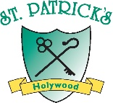
May-June 2022
Newsletter

Dear Parents, Carers, Boys & Girls,

Welcome to our May Newsletter and let’s hope that the weather picks up in the next few weeks, so that we can enjoy a wide range of summer activities.
Thankfully, the Covid situation has eased in school, over the past few weeks. It was so lovely to see the children get together in their year groups and mixing with everyone. The children have been enjoying their Shared Education trips to Lorne in Sea hill and what a lovely place it is to have on our doorstep.

As we enter the summer months, we are organising a Tallest Sunflower Competition for the best class in school and every child will get a few seeds to bring home to grow. Growing Instructions are attached to the newsletter. Good luck and prizes for the tallest plant in each class will be awarded.

Thank you for your continued support throughout the Covid situation, we have emerged as a stronger school community. Thankfully, we will have lots of activities to fill up the remaining weeks of the term.

Kind regards

C O’Neill

Update to Current Covid regulations

As a school community, we are continuing our journey towards a normal school day, although, it sometimes difficult to remember what that actual was like!!!
Accessing the school grounds

The following change will commence immediately on Monday 16thMay.

The main school gates will be for vehicle access only.
ALL pupils and parents, including cyclists should use the pedestrian access points only at Ean Hill, Crossing Patrol Double gates and Canopy gate.
Unfortunately, the church side gate remains closed, as it doesn’t close properly.

The following changes will commence on Monday 30th May.

Starting the day
From Mon 30th May - all classes will start at 8:45 with morning prayers registration tasks and dinners from 8:45 – 9:00am. Teaching will start at 9am.

Entering the school building

PLEASE NOTE

P1 Children – parents should stay with their child and hand them over to the class teacher /CA, via the P1 green door at side of school, this has been very beneficial for the P1 teachers and the children.

P2 – P7 Children should enter by main doors and canopy side only and go directly to cloakrooms, then straight to their classrooms for registration.

Finishing school

P1 -3 classes will finish at 2pm.
P1’s will exit by their usual green door at P1 side of school.
P2, P2/3 and P2/3 will all exit via the canopy door.

P4-7 classes will finish at 3pm.
P4, P4/5 will exit via the canopy door. –
P5, P6 and P6/7 children will exit via their usual exit door at the extension.
P7 pupils will continue to exit by the side steps.

Early Finish on a Friday
P1-3 finish at 1:45pm
P4-7 Finish at 2pm

See – Saw Messaging App – has been a very useful communication tool throughout the Pandemic and while we will continue to use See – Saw tool, it is expected that the teaching staff will continue to manage two – way communications, during their contracted hours of work, which will be from 8:45 to 4pm, Mon – Friday.

It will take a little bit of time to adapt to the full return to normality!

P7 Activities

P7 Leaver Hoodies
The P7 Leavers Hoodies have been ordered and should arrive in the next week or so. The hoodies were kindly sponsored by the PTA.

P7 Leavers Photographs – Friday 13th May
The next milestone for our P7 pupils will be their Leaver’s Photograph portraits
There are two formats: - 1. A formal class photograph with their full winter school uniform. 2. A casual image that relates to their interest outside of school e.g. sports kit, musical instrument, artistic flair, reading etc

P7 Summer Show
The P7 Summer show will take place on Wednesday 15th & Thursday 16th June, times TBC, we hope to at least get the pupils’ parents into the School hall, in a social distanced setting.

--------------------------------------------------------------------

New pupils
We welcome Sorcha (P6) Lorcan (P4/5) & Soren (P1A) , Eli & Jude (P6), who all joined our school community after Easter. I am sure they will be made very welcome and soon feel part of the school community.

The school continues to be very popular, with families re locating to the Holywood area. It has been very busy with enquires, in the past few weeks.

School Reports June 2022
Individual pupil reports will be issued towards the end of the summer term. The report will return to the normal curriculum areas, as per the DENI schedule.

School Year 2022/23
An update on the next school year 2022/23, including an outline of class provision for 2022-2023 will be made available on the school website,on Thursday 23rd June, subject to DENI School Budget final allocation.

It is planned to operate with the same class structures for 2022/2023.

Your child’s class allocation will be included with their school report.

If you have a very specific question, it would be appreciated, if you could send in an email: coneill951@c2kni.net

School PE Uniform POP-UP SHOP
Work wear will host a POP-UP SHOP on Wednesday 22nd June 1- 3:30pm in the assembly hall at the school. CASH ONLY.

____________________________________________________________

ECO GARDEN PROJECT - DIY SOS SPH

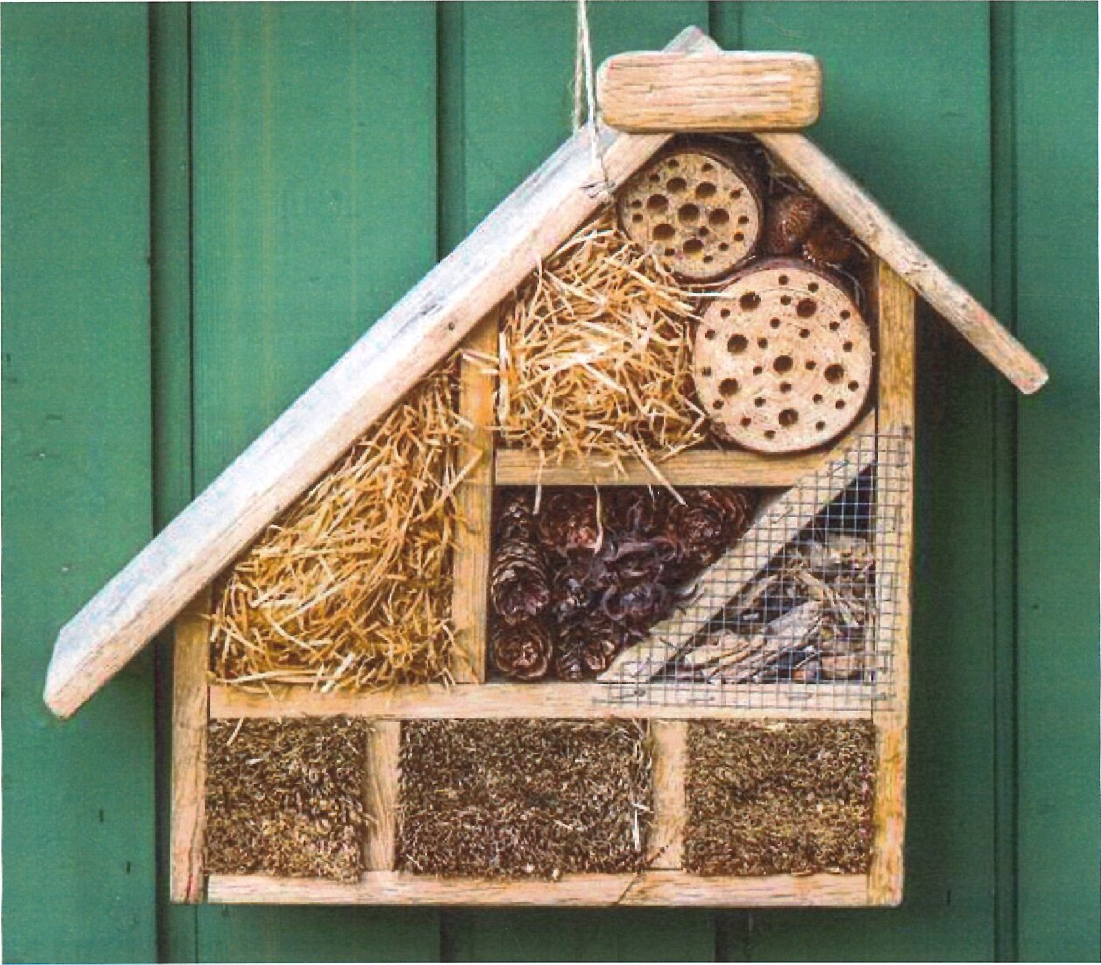
In term one, our application to Groundworks funding for our Eco Project was knocked back and received no funding. In the interim, Beautiful NI & Danske Bank included the school in an Eco project which involved some planting of fruit trees and hedges (on Ean Hill side) and a seating area, under the big chestnut trees. This project will continue from an educational perspective until June 2022.
The work is beginning to take shape with the renewal of the garden fencing and the completion of the outdoor classroom. This is a welcome start but the project needs impetus and additional support.

Some additional funding providers have been approached, however, I think the best way to proceed with the plan, is another DIY–SOS approach, where the school community take on the task of creating environmental projects around the school grounds.
We had a great day last October! This would involve using all the expertise that we have in our school community to create an eco-space, support from the PTA and school community to provide materials and labour to complete the task.
‘_____________________________________________________

Standardised Testing Update

Pupils from P3 to P6 completed their Standardised tests in Maths in English, this week.

Standardised testing is used in all schools to measure the level of progress made by each individual pupil, class and year groups. In school, we use three tests GL Progress in Maths (PTM), Progress in English(PTE) and CAT4. The range of scores in standardised test range from 69 to 141. They are calculated to give age equivalent scores and make very small allowances for dates of birth and gender.

As a school, we use the data generated to make a comparison from one year to the next, on how each individual pupil, class and year groups make progress.

A score of 100 points is deemed an average score in standardisation. Two-thirds of all pupils will be in the 95 to 105 scoring band.
One-sixth of all pupils will score above 105 and one sixth will score below 95. This is the normal bell curve of standardisation scores.
Generally, pupils should improve by between 3 and 5 points per year.

These scores are a very reliable indicator as to your child’s academic performance. This is measured against their Cognitive Ability Test score (called CAT4 or NRIT), which indicates a child’s overall academic ability. As a school we use these three scores to measure the level of progress made by each pupil. A pupil’s CAT4 score should be commensurate with their PTE and PTM scores.

Due to Covid, we had to make a few changes to the standardised testing programme for 2020/21. However, in 2021/22, we have managed to return to our normal cycle of testing.

Your child’s scores will be reported to you in the end of year report. These will form the basis of your child’s baseline PTM in October 2022.


School Sports Days

Provisional arrangements for Sports days are as follows

Thursday 26th May | P1-2 | 9:30 -11am @ school  Children finish the day @ 11am
Wednesday 1st June | P 3-7 | 9:30 – 12:00 @ St.Paul’s Grounds  Children finish the day @ 12:00
And are subject to the wonderful NI weather, of course!!

Please check the school website calendar for all updated events.

https://www.stpatrickspsholywood.com/parents/calendar/?calyear=2021&calmonth=5&

- Please note school will be closed on 2nd, 3rd & 6th June for bank Holiday weekend and a staff development day.

BUG CLUB CHALLENGE

The winning class for the Spring Term 2 was Mrs O’Neill’s P6 class. Well done to everyone in P6 and the girls and boys have selected a movie afternoon with treats for their prize.

For the summer term, any child (P4,P4/5, P5, P6 & P6/7) who has read every book assigned to them for their reading homework, will win a prize

And finally….

Trócaire – Fundraising Campaign during Lent.

Thank you to everyone who participated in the Trócaire Campaign. There was a fantastic response to all the fund raising activities and I am delighted to record that as a school community, we have raised £2 375, for the appeal. Well done to every class in the school! This is a remarkable level of generosity from the school community. A presentation will be made to Trócaire in the next few weeks.

