Google Meet Guide for Students
Before you start try to find a quiet place where you won’t be
disturbed and where you have good wifi connection.
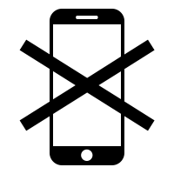
Make sure any extra devices are switched off so you won’t be
distracted.
Have all you need ready e.g. pen and exercise book or web links

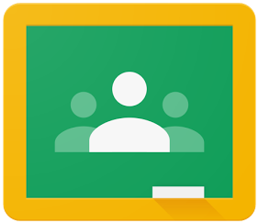
In Google Classroom, click on the Meet link. It may be in the
Banner or your teacher may have posted it to the Stream.
Sign in with your C2k account.

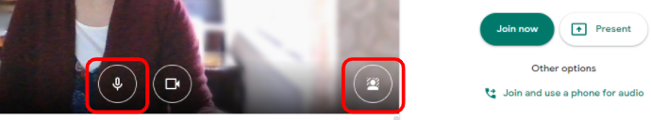
Before joining
click on
the
Mic
icon to mute

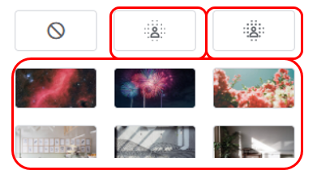
Click on the Change Background icon.
You can:

- Slightly blur your background
- blur your background
- choose from a selection of background images
Read any instructions from your teacher in the Chat

Answer any questions from your teacher in the Chat or Q & A
Pay attention and wait for your teacher to ask you to unmute.
Look at your device’s camera when you are talking.

